Epsom & Ewell F.C.
18
v
Colliers Wood United / Banstead Athletic
Friday, 30th March 2018 – 11.30 a.m.
Monday, 2nd April 2018 – 11.30 a.m.
Good morning! If you are reading this on Good Friday, then welcome to High Road for our League match against Colliers Wood United. If it is Easter Monday then welcome to High Road for our League match against Banstead Athletic! We welcome the players, supporters and officials of both clubs and wish them a safe journey home, as of course we do for our own regular supporters.

These two matches are extremely important ones for us as we need two wins to stand any chance whatsoever of closing the gap on the teams above us, of which they are two. For that reason it should not be overlooked that these are equally vital matches for our opponents as three clubs could go down this season, so both will be looking at their visit here as an important opportunity to climb away from the relegation places.

Colliers Wood United are currently the team with the longest tenure in this division, while Banstead are in their first season back at this level, following promotion from Division One last term. The latter have of course visited us one before this season when they defeated us 2-1 in the F.A. Cup back in August. We also visited Merland Rise later that month where a late equaliser in a 1-1 draw denied us all three points. We last met the Wood in August for a Friday evening match where they led 4-0 at the break, eventually winning 5-2.

We were last here on Saturday when Bedfont Sports visited us. They had defeated us 7-0 back in November at the Bedfont Sports Club but this time we gave them a much tougher battle and were defeated 4-2, although I thought we were worth a draw. It is definitely time for our luck to change. Maybe this weekend?

Following these matches we make a visit to the Spectrum for a League match against Guildford City and return here seven days later for the visit of Champions elect Westfield.

Our anniversary month is almost complete but we are still marking our Centenary all year. We will shortly be announcing our Centenary Dinner and releasing details and should have our Centenary kit on show shortly too. We are still looking for match and player sponsors, so please let a Committee Member know if you would like to do this and help your club at the same time.

Enjoy the game!

Rich

Don’t forget, you can now follow us on Social Media. Please see the inside cover for addresses.

Cover photo by Gemma Jarman

- Scott Murphy’s free kick finds the net for our second goal against Bedfont Sports

1
Cherry Red Records Combined Counties League
Premier Division Table 2017/18
inc Tuesday 27th March | P | W | D | L | F | A | Pts | GD | H | A
Westfield | 33 | 30 | 1 | 2 | 126 | 31 | 91 | +95 | 14/4 | 0-5
Bedfont Sports | 36 | 25 | 5 | 6 | 92 | 53 | 80 | +39 | 24/3 | 0-7
Sutton Common Rovers | 35 | 25 | 3 | 7 | 82 | 39 | 78 | +43 | 0-2 | 0-5
Walton & Hersham | 35 | 20 | 6 | 9 | 70 | 47 | 66 | +23 | 0-2 | 24/4
Camberley Town | 36 | 11 | 20 | 5 | 45 | 36 | 53 | +9 | 0-0 | 1-1
CB Hounslow United | 32 | 15 | 4 | 13 | 60 | 46 | 49 | +14 | 17/4 | 2-4
Knaphill | 33 | 13 | 10 | 10 | 61 | 53 | 49 | +8 | 0-0 | 2-6
Redhill | 34 | 15 | 4 | 15 | 62 | 56 | 49 | +6 | 0-5 | 0-3
Spelthorne Sports | 36 | 14 | 7 | 15 | 59 | 55 | 49 | +4 | 1-5 | 0-0
Horley Town | 34 | 14 | 7 | 13 | 53 | 66 | 49 | -13 | 2-3 | 2-3
Balham | 29 | 14 | 5 | 10 | 59 | 48 | 47 | +11 | 0-2 | 0-4
Abbey Rangers | 33 | 11 | 9 | 13 | 50 | 50 | 42 | 0 | 1-1 | 0-0
Hanworth Villa | 33 | 11 | 9 | 13 | 55 | 69 | 42 | -14 | 1-1 | 3-2
North Greenford United | 28 | 11 | 8 | 9 | 49 | 43 | 41 | +6 | 1-2 | 19/4
Guildford City | 35 | 11 | 7 | 17 | 58 | 76 | 40 | -18 | 1-3 | 7/4
Colliers Wood United | 32 | 10 | 4 | 18 | 54 | 58 | 34 | -5 | 30/3 | 2-5
AFC Hayes | 31 | 9 | 6 | 16 | 44 | 63 | 33 | -19 | 28/4 | 0-2
Chertsey Town | 34 | 9 | 5 | 20 | 54 | 77 | 32 | -23 | 2-7 | 0-1
Godalming Town | 34 | 8 | 6 | 20 | 43 | 74 | 30 | -31 | 0-3 | 2-1
Banstead Athletic | 33 | 8 | 6 | 19 | 41 | 79 | 30 | -38 | 2/4 | 1-1
Farnham Town | 34 | 5 | 9 | 20 | 42 | 78 | 24 | -36 | 3-0 | 0-0
Epsom and Ewell | 34 | 3 | 9 | 22 | 29 | 90 | 18 | -61 | X | X

Lucky Day? – 30th March
Played 17 - Won 9 Drawn 3 Lost 5 - For 27 Against 22 - PPG 1.76 - Good
Our Club record against Colliers Wood United
Played 24 - Won 14 Drawn 2 Lost 8 - For 47 Against 39 - PPG 1.83 - Good
Our Largest wins and losses against Colliers Wood United
8th March 2014 - Won 4-0 - Combined Counties League (H)
26th August 2016 - Lost 0-5 - Combined Counties League (A)
Colliers Wood United’s Last Visit
Friday 14th April 2017 - Lost 0-1 - Combined Counties League

Lucky Day? – 2nd April
Played 18 - Won 5 Drawn 6 Lost 7 - For 25 Against 29 - PPG 1.17 - Below Average
Our Club record against Banstead Athletic
Played 38 - Won 23 Drawn 7 Lost 8 - For 62 Against 38 - PPG 2.00 - Very Good
Our Largest wins and losses against Banstead Athletic
27th December 2008 - Won 5-0 - Combined Counties League (A)
21st April 2003 - Lost 0-4 - Isthmian League Division One South (A)
Banstead Athletic‘s Last Visit
Sunday 6th August 2017 - Lost 1-2 - F.A. Cup Extra-Preliminary Round

First Eleven Appearances 2017/18 - (max 40)
Name | Debut | 2017/18 |  |  |  | Career Totals
 |  | App | Sub | Tot | Goals | App | Sub | Tot | Goals
AJAYI Tayo* | 06/08/2017 | 3 | 4 | 7 | 1 | 3 | 4 | 7 | 1
ANDERSON Miguel | 03/02/2018 | 4 | 2 | 6 | 0 | 4 | 2 | 6 | 0
BROOKS Jordan* | 06/08/2017 | 3 | 0 | 3 | 0 | 3 | 0 | 3 | 0
BURROWES Joshua* | 02/12/2017 | 1 | 1 | 2 | 0 | 1 | 1 | 2 | 0
CASTELL Cristian* | 06/08/2017 | 2 | 4 | 6 | 0 | 2 | 4 | 6 | 0
CAULCRICK Joshua | 17/02/2018 | 0 | 1 | 1 | 0 | 0 | 1 | 1 | 0
CLARK Jordan | 17/02/2018 | 0 | 2 | 2 | 0 | 0 | 2 | 2 | 0
CONNELLY Lloyd | 14/10/2017 | 23 | 3 | 26 | 2 | 23 | 3 | 26 | 2
DEWAR Ali* | 29/10/2011 | 1 | 2 | 3 | 0 | 56 | 42 | 98 | 10
DOBRAJ Endrit | 18/11/2017 | 13 | 3 | 16 | 0 | 13 | 3 | 16 | 0
DYSON Ben | 12/08/2017 | 23 | 10 | 33 | 2 | 23 | 10 | 33 | 2
FRANKLIN Ben | 03/03/2015 | 3 | 1 | 4 | 0 | 4 | 1 | 5 | 0
GRAHAM Bentley* | 09/02/2016 | 3 | 0 | 3 | 0 | 20 | 1 | 21 | 3
GRANDISON Kane* | 11/11/2017 | 7 | 1 | 8 | 0 | 7 | 1 | 8 | 0
GRIFFIN Reisse | 08/08/2015 | 25 | 0 | 25 | 1 | 98 | 13 | 111 | 7
HARLAND-GODDARD Tom* | 06/08/2017 | 1 | 1 | 2 | 0 | 1 | 1 | 2 | 0
HARRIS Colin* | 04/08/2012 | 9 | 0 | 9 | 0 | 34 | 0 | 34 | 0
HATFIELD Jamie* | 11/11/2006 | 9 | 1 | 10 | 0 | 258 | 14 | 272 | 6
HAYWARD Ben* | 07/03/2007 | 5 | 1 | 6 | 0 | 248 | 29 | 277 | 18
HEAGNEY Adam | 16/08/2016 | 24 | 3 | 27 | 0 | 61 | 12 | 73 | 1
HENDRY Rob* | 08/08/2015 | 16 | 1 | 17 | 5 | 84 | 23 | 107 | 28
HOUGH Kyle* | 14/08/2007 | 10 | 2 | 12 | 6 | 343 | 21 | 364 | 207
JASPER Joe* | 11/11/2017 | 0 | 1 | 1 | 0 | 0 | 1 | 1 | 0
JEANNOEL Germaine | 02/12/2017 | 2 | 5 | 7 | 1 | 2 | 5 | 7 | 1
KENNEDY Calum | 18/11/2017 | 2 | 1 | 3 | 0 | 2 | 1 | 3 | 0
LAW Franky* | 06/08/2017 | 3 | 0 | 3 | 0 | 3 | 0 | 3 | 0
LOFTUS-CHEEK Joe | 06/08/2017 | 10 | 5 | 15 | 2 | 10 | 5 | 15 | 2
MACAULEY Alvin | 10/03/2018 | 0 | 1 | 1 | 0 | 0 | 1 | 1 | 0
MARKS Samuel* | 06/01/2018 | 1 | 2 | 3 | 0 | 1 | 2 | 3 | 0
MARVELL Dale* | 15/01/2000 | 17 | 2 | 19 | 0 | 286 | 51 | 337 | 86
MASTERSON Shaun | 25/11/2017 | 5 | 3 | 8 | 0 | 5 | 3 | 8 | 0
MCKAY Alex | 20/12/2008 | 25 | 1 | 26 | 1 | 156 | 38 | 194 | 13
MULLINGS Corey* | 23/12/2017 | 0 | 2 | 2 | 0 | 0 | 2 | 2 | 0
MURPHY George | 19/03/2013 | 2 | 0 | 2 | 0 | 70 | 7 | 77 | 3
MURPHY Scott | 20/01/2007 | 27 | 0 | 27 | 2 | 39 | 2 | 41 | 3
MYERS Antony* | 23/12/2006 | 1 | 0 | 1 | 0 | 76 | 33 | 109 | 9
NICHOLAS Kyen | 13/01/2018 | 8 | 2 | 10 | 3 | 8 | 2 | 10 | 3
NWACHUKWU Jason* | 01/10/2016 | 9 | 4 | 13 | 2 | 26 | 20 | 46 | 3
O'BRIEN Louis | 28/08/2017 | 1 | 5 | 6 | 0 | 1 | 5 | 6 | 0
PINDER Marlon | 13/01/2018 | 7 | 0 | 7 | 1 | 7 | 0 | 7 | 1
ROBERTS Liam | 12/08/2017 | 20 | 9 | 29 | 4 | 20 | 9 | 29 | 4
ROBINSON Sam* | 22/10/2011 | 5 | 0 | 5 | 0 | 66 | 6 | 72 | 14
ROSE Daniel* | 25/10/2016 | 14 | 2 | 16 | 1 | 16 | 7 | 23 | 1
SAMPAT Mohammed* | 23/12/2017 | 3 | 0 | 3 | 0 | 3 | 0 | 3 | 0
SELLICK Rory | 27/01/2018 | 6 | 0 | 6 | 1 | 6 | 0 | 6 | 1
SMITH Andy* | 25/08/2017 | 2 | 0 | 2 | 0 | 2 | 0 | 2 | 0
SMITH Taryn | 28/10/2017 | 7 | 3 | 10 | 0 | 7 | 3 | 10 | 0
STEW-LEWIS Noah | 09/12/2017 | 6 | 2 | 8 | 0 | 6 | 2 | 8 | 0
THOMPSON Ashley | 21/08/2017 | 29 | 1 | 30 | 4 | 29 | 1 | 30 | 4
THOMPSON Elliott | 09/02/2016 | 1 | 0 | 1 | 0 | 8 | 9 | 17 | 1
THOMSON David* | 02/09/2017 | 2 | 2 | 4 | 0 | 2 | 2 | 4 | 0
TURPIE Ali | 31/03/2016 | 1 | 0 | 1 | 0 | 12 | 1 | 13 | 0
WHITE Sean | 02/08/2014 | 14 | 7 | 21 | 2 | 20 | 20 | 40 | 5
YOUNG Conor | 07/03/2015 | 25 | 0 | 25 | 0 | 26 | 0 | 26 | 0

Recent Results and Fixtures
Combined Counties League – Thursday 24th March 2018
North Greenford United | 1-1 | Camberley Town
Combined Counties League Cup SF – Saturday 24th March 2018
Worcester Park | 3-2 | Sutton Common Rovers
Combined Counties League – Saturday 24th March 2018
Abbey Rangers | 2-1 | Horley Town
AFC Hayes | 3-2 | Guildford City
CB Hounslow United | 5-1 | Chertsey Town
Colliers Wood United | 0-1 | North Greenford United
Epsom & Ewell | 2-4 | Bedfont Sports
Farnham Town | 1-1 | Knaphill
Godalming Town | 2-4 | Spelthorne Sports
Hanworth Villa | 0-3 | Redhill
Westfield | 7-1 | Banstead Athletic
Combined Counties League – Tuesday 27th March 2018
Camberley Town | 0-1 | Sutton Common Rovers
Farnham Town | 0-4 | Redhill
Westfield | 4-0 | Walton & Hersham
Combined Counties League – Thursday 29th March 2018
AFC Hayes | V | Abbey Rangers
Banstead Athletic | V | North Greenford United
Knaphill | V | CB Hounslow United
Combined Counties League – Friday 30th March 2018
Epsom & Ewell | V | Colliers Wood United
Combined Counties League – Saturday 31st March 2018
Abbey Rangers | V | Walton & Hersham
Banstead Athletic | V | Balham
Camberley Town | V | Westfield
Hanworth Villa | V | AFC Hayes
Horley Town | V | Guildford City
Knaphill | V | Godalming Town
North Greenford United | V | CB Hounslow United
Spelthorne Sports | V | Farnham Town
Sutton Common Rovers | V | Redhill
Combined Counties League – Monday 2nd April 2018 – (11.30 a.m. k.o.)
AFC Hayes | V | North Greenford United
Balham | V | Sutton Common Rovers
CB Hounslow United | V | Bedfont Sports
Chertsey Town | V | Abbey Rangers
Epsom & Ewell | V | Banstead Athletic
Farnham Town | V | Camberley Town
Guildford City | V | Godalming Town
Redhill | V | Horley Town
Westfield | V | Knaphill
Recent Results and Fixtures
Combined Counties League – Tuesday 3rd April 2018
Walton & Hersham | V | Spelthorne Sports
Combined Counties League – Wednesday 4th April 2018
Colliers Wood United | V | Hanworth Villa
Combined Counties League – Thursday 5th April 2018
Chertsey Town | V | Balham
Combined Counties League – Saturday 7th April 2018
AFC Hayes | V | Farnham Town
Balham | V | Abbey Rangers
Banstead Athletic | V | Spelthorne Sports
Camberley Town | V | Hanworth Villa
CB Hounslow United | V | Knaphill
Chertsey Town | V | Godalming Town
Guildford City | V | Epsom & Ewell
Redhill | V | North Greenford United
Sutton Common Rovers | V | Bedfont Sports
Westfield | V | Colliers Wood United
Combined Counties League – Tuesday 10th April 2018
Balham | V | CB Hounslow United
Banstead Athletic | V | Sutton Common Rovers
North Greenford United | V | Godalming Town
Redhill | V | AFC Hayes
Walton & Hersham | V | Horley Town
Westfield | V | Chertsey Town
Combined Counties League – Wednesday 11th April 2018
Colliers Wood United | V | Abbey Rangers
Combined Counties League – Thursday 12th April 2018
Balham | V | Farnham Town
Combined Counties League – Friday 13th April 2018
Colliers Wood United | V | Walton & Hersham
Combined Counties League – Saturday 14th April 2018
Abbey Rangers | V | Redhill
Bedfont Sports | V | Banstead Athletic
Camberley Town | V | AFC Hayes
Epsom & Ewell | V | Westfield
Farnham Town | V | Guildford City
Godalming Town | V | Sutton Common Rovers
Horley Town | V | CB Hounslow United
Knaphill | V | Chertsey Town
North Greenford United | V | Balham
Spelthorne Sports | V | Hanworth Villa
Combined Counties League – Tuesday 17th April 2018
Epsom & Ewell | V | CB Hounslow United

From behind the goal
Epsom & Ewell 2-4 Bedfont Sports
Combined Counties League - Premier Division - Saturday 24th March 2018

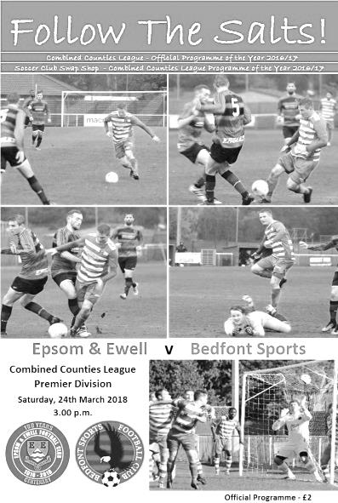
Much improved performance but no reward

Back in November we visited the Bedfont Sports Club and were hammered 7-0 by the best team I thought we had faced this season. However, in the return match at High Road on Saturday we battled our promotion chasing opponents all the way and the score line really doesn't do justice to the performance, which may have been our best so far in 2018.

This performance was achieved despite the absence of Kyen Nicholas and Marlon Pinder, while Adam Heagney was dropped to the bench. In his place Reisse Griffin moved over to the centre of defence with Shaun Masterson coming back into the starting eleven on the left, while Ben Dyson and Liam Roberts came in up front and had their best games in quite a while. Roberts in particular was thrown in at centre forward and whilst lacking the size of our regular front man he competed throughout and held the ball up quite well. Most importantly though, it was great to see the return of Elliott Thompson, who has worked very hard to get back to fitness, following a horrible knee injury at Windsor over a year and a half ago in August 2016!

The visitors also provided a bit of a surprise in their line-up by including our former player Jason Nwachukwu, who struggled to hold a regular place in his time at our club, although he had the final say by earning a penalty and scoring another goal to consign us to another defeat.

The opening proceedings were fairly even with our Captain Alex McKay finding space in the penalty area to meet a Thompson corner but he was only able to volley the ball well over the bar. In response Nwachukwu fired wide at the other end. The visitors had passed the ball around and left us chasing shadows back in Middlesex, but they went with a more aerial attack in this encounter and we were dealing with it fairly well. Unfortunately in the 13th minute Griffin tried to shield Nwachukwu off the ball, but he wriggled past him and as he got in on goal was clumsily brought down, leaving a very easy decision for the referee. Jack Mills took a clinical penalty and gave Conor Young no chance.

A couple of chances for the opposition followed soon after this with a couple of strikes that were not too far away from our goal; the second of which was a 25 yard volley from Jamie Read that would have been quite special had it gone in. However, we were back on terms very shortly afterwards when another corner was only half cleared. The ball was fed back in where Ashley Thompson took a touch to control it and he then smashed it into the net off

the crossbar in the 24th minute.

We deserved to be level at that stage but Bedfont Sports picked up the pace again and regained their lead in the 33rd minute with an attack down the right which was squared across goal to the far post where Alex Rose struck at goal, only to see the ball fly into the net off the unlucky Endrit Dobraj. We could and should have been back on terms just three minutes later when a perfect far post cross from the left was met by Lloyd Connelly but his header just glanced the ball across goal from just six yards out when a fuller contact would surely have resulted in a goal. We paid for this miss almost immediately as Nwachukwu was given the freedom of the park to run in at goal from an angle and bend his shot around the advancing Young to go 3-1 up.

After seeing no goals at all in the first half of our last four matches, we had four to contend with, and it wasn't over yet as the best was yet to come. In the 41st minute Roberts was unceremoniously dumped on the edge of the area and Scott Murphy stepped up and curled a beauty into the top left corner of Rourke Pickford's net. It was a special strike and proved that it is possible to get the ball up and down again from the edge of the area, even when the referee only moves the players six yards back!

Roberts nearly got his header on target a couple of minutes later but it was a difficult chance and we went in at the half trailing. As the players went in at the half there seemed to be a bit of a disturbance, the upshot of which was that we made a change at the start of the second half with Dobraj replaced by Heagney. The game continued to be fairly even, although Nwachukwu nearly extended his lead as he got through on goal only to slice his shot wide of Young's left post.

We responded with a great pass from Thompson that put Dyson through on goal but just as he was about to get his foot to the ball the defender made an important tackle. The game continued to swing from end to end and Griffin was well placed to head a dangerous ball away with two strikers waiting at the far post and then Nwachukwu chased a long ball and got there ahead of Young but his touch took him a little wide and McKay shepherded him away from the empty net.

As time began to run out on us, substitute Joe Loftus-Cheek went in for a challenge with Pickford and distracted him sufficiently so that his punch fell straight to Dyson just twelve yards out, but his shot was blocked by a defender standing a couple of yards out from goal and Roberts' follow-up was charged down. Regrettably in the 93rd minute the score was extended to 4-2 as Young got the ball caught under his studs and was tackled by Matt Riggs who rolled the ball into the empty net from 20 yards.

The fourth goal was particularly harsh on our boys as we had been pushing the opposition back in our hunt for an equaliser that I felt we would have deserved, but like so many matches in recent weeks we have just fallen short and we now turn our attention to an extremely pivotal pair of Easter fixtures, weather permitting.

Epsom and Ewell: Conor Young, Endrit Dobraj, Shaun Masterson, Reisse Griffin,
Alex McKay (c), Ashley Thompson, Ben Dyson, Scott Murphy, Liam Roberts,
Elliott Thompson, Lloyd Connelly

Subs: Adam Heagney for Dobraj (46), Louis O'Brien for Thompson (64),
Joe Loftus-Cheek for Connelly (75)

Club Records - 30th March
Date | Day | Competition |  | Opponents |  | Scorers
30/03/29 | Sat | Friendly | H | Tottenham Res | 3-6 | F.Behn, G.Carmichael (2)
30/03/34 | Fri | London League | A | Tooting & Mitcham | 1-1 | L.Marlow
30/03/35 | Sat | London League | A | Chelmsford | 1-6 | H.Pullen
30/03/46 | Sat | Friendly | H | Redhill | 3-0 | G.Brogdale (2), S.Scott (pen)
30/03/57 | Sat | Corinthian Memorial  Shield SF | A | Chesham United | 1-0 | J.Bangs
30/03/63 | Sat | Corinthian League | A | Horsham | 3-1 | J.O'Shea (2), L.Pritchard
30/03/66 | Wed | Athenian League 2 | H | Ware | 5-0 | A.Cox (3), P.Scott (2)
30/03/68 | Sat | Athenian League 2 | A | Harrow Borough | 0-1
30/03/70 | Mon | Athenian League 2 | A | Edgware Town | 0-1
30/03/74 | Sat | Surrey Senior League | H | Cobham | 3-1 | D.Ritman (pen), B.Jones, T.Tuite
30/03/82 | Tue | Isthmian League 1 | H | Walton & Hersham | 1-1 | R.Murphy
30/03/85 | Sat | Isthmian League  Premier Division | A | Hitchin Town | 1-0 | T.Tuite
30/03/91 | Sat | Isthmian League 2s | H | Chertsey Town | 1-0 | T.Tweedy
30/03/93 | Tue | Isthmian League 3 | H | Collier Row | 1-0 | P.Meredith
30/03/96 | Sat | Isthmian League 3 | A | Horsham | 1-3 | P.Meredith
30/03/99 | Tue | Isthmian League 3 | H | Lewes | 1-0 | S.Grant
30/03/13 | Sat | Combined Counties Premier Division | A | Farnham Town | 1-1 | K.Hough
Historical Decades
90 years ago – Epsom Town F.C.
31/03/28 | Sat | London League | A | Millwall United | 2-0 | J.Parr, R.Marlow
80 years ago – Epsom F.C.
26/03/38 | Sat | London League | H | P.O.Engineers | 3-0 | B.Solly, J.Jones, G.Collins
70 years ago – Epsom F.C.
29/03/48 | Mon | London League | H | Woolwich Poly | 1-0 | T.Rochester
60 years ago – Epsom F.C.
29/03/58 | Sat | Corinthian League | A | Maidenhead United | 0-3
50 years ago – Epsom & Ewell F.C.
30/03/68 | Sat | Athenian League 2 | A | Harrow Borough | 0-1
40 years ago – Epsom & Ewell F.C.
27/03/78 | Mon | Isthmian League 2 | A | Tring Town | 2-2 | R.Parkin, T.Tuite
30 years ago – Epsom & Ewell F.C.
29/03/88 | Tue | Isthmian League 2s | H | Camberley Town | 3-1 | M.Cossey (2), S.Flack
20 years ago – Epsom & Ewell F.C.
28/03/98 | Sat | Isthmian League 3 | H | East Thurrock United | 7-2 | A.Boxall (3), A.Nimmo (2), A.Rawlinson, K.Webb
10 years ago – Epsom & Ewell F.C.
29/03/08 | Sat | Combined Counties Premier Division | A | Bedfont Green | 2-0 | R.Burns, K.Hough (pen)

History Corner – 30th March
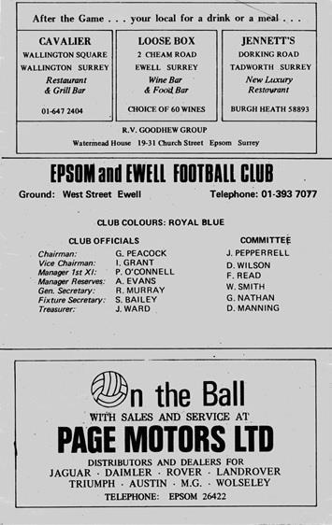
90 years ago this week we continued our push for the London League title with a 2-0 win over Millwall United. We know very little about Millwall United except that they appeared to play at the Lockes Sports Ground on the Isle of Dogs. Jack Parr and Reg Marlow were our scorers that day.

89 years ago today we hosted Tottenham Hotspur’s reserve side in a friendly, losing 6-3 at West Street. They sent quite a strong team to play us including five players with first team experience. The local papers said that one of these, Handley, was responsible for all six goals!

84 years ago today we visited Sandy Lane for our traditional Good Friday fixture with Tooting & Mitcham United, drawing 1-1. We led despite an early ankle injury to Tommy Winship that rendered him a passenger until he eventually had to leave the field on the hour. The injury was so bad though he would miss the remainder of the season! With ten men on the field, the home side, including future Epsom scoring legend Jackie Pullen, forced the equaliser

52 years ago today we were at home to Ware in an Athenian League match, winning 5-0. Alan Cox scored a hat trick while Peter Scott got the other two goals. We would repeat the same scoreline on an Easter weekend in 1981!

44 years ago today we were at home to Cobham in a Surrey Senior League match, winning 3-1. Our goals came from Barry Jones, Tommy Tuite and a Dave Ritman penalty (see programme left) but our Manager Pat O’Connell was more interested in a young lad playing for the opposition by the name of Trevor Lee. Five months later, he and his mate Phil Walker would be lining up for Epsom & Ewell as we would commence the very successful 1974/75 season.

33 years ago today Tommy Tuite scored his 350th goal for the club four minutes from time as we defeated Hitchin Town 1-0 in the Isthmian League Premier Division on our first visit to Top Field. We had secured our first ever win in the top flight over the Canaries back in November, but by this stage of the season we were comfortably settled in midtable. Guest of honour that day was a 90 year old Sir Stanley Rous, former Head of F.I.F.A. back in the days when the position actually meant something other than suspicion!

20 years ago this week we hosted East Thurrock United in a League match at Merland Rise and crushed them 7-2. Andy Boxall was destroyer-in-chief with a hat trick, while Andy Nimmo scored twice and Andy Rawlinson and Kevin Webb scored the other goals.

Club Records - 2nd April
Date | Day | Competition |  | Opponents |  | Scorers
02/04/27 | Sat | Surrey Senior League | A | Guildford | 2-2 | F.Ryding, F.Behn
02/04/32 | Sat | London League | A | Park Royal | 1-2 | B.Williams
02/04/34 | Mon | London League | H | Tooting & Mitcham United | 0-0
02/04/38 | Sat | London League | A | Bostall Heath | 1-0 | B.Solly
02/04/49 | Sat | London League | H | Tilbury | 3-4 | B.Cutter, F.Marshall, K.Minter
02/04/55 | Sat | Corinthian League | A | Hounslow Town | 0-3
02/04/56 | Mon | Corinthian League | A | Worthing | 2-1 | R.Colfar, D.Hermitage
02/04/60 | Sat | Corinthian League | H | Dorking | 0-4
02/04/66 | Sat | Athenian League 2 | H | Edmonton | 3-1 | B.Harding (pen), A.Cox, K.Welham
02/04/68 | Tue | Athenian League 2 | A | Horsham | 2-3 | J.McNaught, J.Eales
02/04/74 | Tue | Surrey Senior League | A | Lion Sports | 1-2 | A.Webb
02/04/77 | Sat | Athenian League 1 | H | Ruislip Manor | 0-0
02/04/83 | Sat | Isthmian League 1 | H | Worthing | 4-2 | S.Hill (3), M.Stratford
02/04/88 | Sat | Isthmian League 2s | H | Feltham | 0-0
02/04/94 | Sat | Isthmian League 3 | A | Tring Town | 0-0
02/04/96 | Tue | Isthmian League 3 | H | Hertford Town | 1-1 | P.Meredith
02/04/05 | Sat | Isthmian League 2 | A | Abingdon Town | 0-3
02/04/16 | Sat | Combined Counties  Premier Division | A | Guildford City | 5-1 | K.Hough, D.Cooper-Smith, D.Dean, T.Neale (2)
Historical Decades
Date | Day | Competition |  | Opponents |  | Scorers
90 years ago – Epsom Town F.C.
31/03/28 | Sat | London League | A | Millwall United | 2-0 | J.Parr, R.Marlow
80 years ago – Epsom F.C.
02/04/38 | Sat | London League | A | Bostall Heath | 1-0 | B.Solly
70 years ago – Epsom F.C.
03/04/48 | Sat | London League | A | Crittall Athletic | 1-3 | L.Hanton
60 years ago – Epsom F.C.
29/03/58 | Sat | Corinthian League | A | Maidenhead United | 0-3
50 years ago – Epsom & Ewell F.C.
02/04/68 | Tue | Athenian League 2 | A | Horsham | 2-3 | J.McNaught, J.Eales
40 years ago – Epsom & Ewell F.C.
01/04/78 | Sat | Isthmian League 2 | H | Camberley Town | 1-1 | T.Coombe
30 years ago – Epsom & Ewell F.C.
02/04/88 | Sat | Isthmian League 2s | H | Feltham | 0-0
20 years ago – Epsom & Ewell F.C.
04/04/98 | Sat | Isthmian League 3 | A | Corinthian Casuals | 1-0 | A.Rawlinson
10 years ago – Epsom & Ewell F.C.
05/04/08 | Sat | Combined Counties  Premier Division | H | Sandhurst Town | 0-2

History Corner – 2nd April
91 years ago today we visited Guildford who had an unbeaten home record in the League and we nearly ended it, leading 2-1 at the half, thanks to goals from F.Ryding and Freddie Behn, but we had to settle for a 2-2 draw. It didn’t matter as within a month we had won the League and added the Cup for good measure a week later!

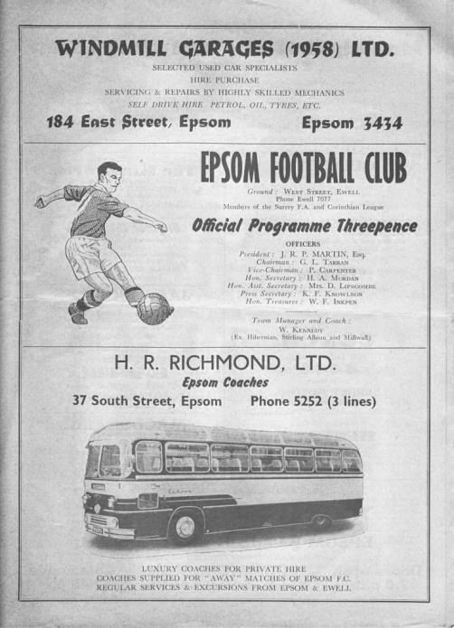
58 years ago today we placed an advert on ITV! We were one of the first clubs to do this and on the Saturday lunchtime, people were advised to come to West Street for a local derby against Dorking. We were in good form and would go on to win the League Cup later that month, but despite a crowd of over 1,000 at West Street we fluffed our lines and lost 4-0!! (see programme left)

40 years ago this week a Tony Coombe free kick scored from inside his own half secured a point at home to Camberley Town in an important Isthmian League Division Two match.

It was almost enough for the win but we couldn’t take any of our other chances and an 89th minute error allowed the Krooners to equalise and pinch a point. It didn’t matter in the end though as we had wrapped up the title by the end of the month; this is still the last time we won a League title.

36 years ago today Steve Hill scored a hat trick as we bashed promotion chasing Worthing 4-2 at West Street. I recall one of his goals being smashed in from an extreme angle! We had been consolidating this season and would launch our promotion charge the following term. However, Worthing would go up this year along with Harlow Town and two days later on the Easter Monday when we visited Woodside Road for the return fixture we were hammered 4-0 in an extremely heavy rain storm.

10 years ago this week we were at home to Sandhurst Town in a League match and lost 2-0 at Merland Rise. The match sponsor that day was a three year old Nathan Lambert who is our mascot against Banstead on Monday, on the occasion of his tenth birthday. There was little else to mention about the match except to say that it was snowing in Epsom that day!

2 years ago today we visited the Spectrum for a League match against Guildford City and I’ll be honest I feared the worst when I saw that Rob Hendry was in goal for us, but we played very well and didn’t leave him with too much to do as we won 5-1 in the end with goals from Kyle Hough, Daryl Cooper-Smith, Dan Dean and a couple from Tom Neale.

CCL Premier Division Club Directory
ABBEY RANGERS Telephone: 01932-422962 - Ground: Addlestone Moor, Addlestone, Surrey KT15 2QH - Colours: Black & White Stripes/Black/Black

A.F.C. HAYES Telephone: 0208-845-0110 - Ground: Farm Park, Kingshill Avenue, Hayes, Middx. UB4 8DD - Colours: Blue and White Stripes/Blue/Blue

BADSHOT LEA Telephone: 01252-320385 - Ground: Ash United FC, Shawfield Stadium, Youngs Drive, Shawfields Road, Ash, Hampshire. GU12 6RE - Colours: Claret/White/Claret

BEDFONT & FELTHAM Telephone: 0208 890 7264 - Ground: The Orchard, Hatton Road, Bedfont, Middx TW14 9QT - Colours: Yellow & Blue/Blue/Blue

BEDFONT SPORTS Telephone: 0208-831-9067 - Ground: Bedfont Sports Club, Hatton Road, Bedfont, Middx TW14 8JA - Colours: Red & Black Hoops/Black/Red & Black Hoops

CAMBERLEY TOWN Telephone: 01276-65392 - Ground: Krooner Park, Wilton Road, Camberley, Surrey. GU15 2QW - Colours: Red & White Stripes/Blue/Red

CB HOUNSLOW UNITED Telephone: 0208 890 7264 - Ground: The Orchard, Hatton Road, Bedfont, Middx TW14 9QT - Colours: Green/Black/Green

CHERTSEY TOWN Telephone: 01932-561774 - Ground: Alwyns Lane, Chertsey, Surrey. KT16 9DW - Colours: Royal Blue & White Stripes/Royal Blue/Royal Blue

COLLIERS WOOD UNITED Telephone: 0208-942 8062 - Ground: Wibbandune Sports Ground, Robin Hood Way, Wimbledon. SW20 0AA - Colours: Blue & Black Stripes/Black/Black
EPSOM & EWELL Telephone: 01737-553250 - Ground: Chipstead FC, High Road, Chipstead, Surrey. CR5 3SF - Colours: Royal Blue & White Hoops/Royal Blue/Royal Blue

FARNHAM TOWN Telephone: 01252-715305 Ground: Memorial Ground, Babbs Mead, West Street, Farnham, Surrey. GU9 7DY Colours: - Claret & Sky Blue /White/ Claret & Sky Blue

GUILDFORD CITY Telephone: 01483-443322 - Ground: The Spectrum, Parkway, Guildford, Surrey. GU1 1UP - Colours: Red & White Stripes/Black/Black

HANWORTH VILLA Telephone: 0208-831-9391 - Ground: Rectory Meadows, Park Road, off Hounslow Road, Hanworth, Middlesex. TW13 6PN - Colours: Red & White Stripes/Black/Black

HARTLEY WINTNEY Telephone: 01252-843586 - Ground: Memorial Playing Fields, Green Lane, Hartley Wintney, Hants RG27 8DL - Colours: Orange & Black/ Orange /Orange

HORLEY TOWN Telephone: 01293-822000 - Ground: The New Defence, Anderson Way, Court Lodge Road, Horley, Surrey. RH6 8SP - Colours: Claret & Sky Blue/Claret/Claret

KNAPHILL Telephone: 01483-475150 - Ground: Brookwood Country Park, Redding Way, Lower Guildford Road, Knaphill, Surrey. GU21 2AY - Colours: Red/Black/Red

NORTH GREENFORD UNITED Telephone: 0208 422 8923 - Ground: Berkeley Fields, Berkeley Avenue, Greenford, Middx UB6 0NX - Colours: Royal Blue & White/Royal Blue/Royal Blue

SUTTON COMMON ROVERS Telephone: 01932-866386 - Ground: Sutton United FC, Gander Green Lane, Sutton, Surrey SM1 2EY - Colours: Yellow/Black/Black

RAYNES PARK VALE Telephone: 020-8540-8843 - Ground: Prince Georges Playing Field, Grand Drive, Raynes Park, London. SW20 9NB - Colours: Blue/Blue/Red

SPELTHORNE SPORTS Telephone: 01932-961055 - Ground: Spelthorne Sports Club, Staines Road, Ashford Common, Ashford, Middx. TW15 1RY - Colours: Light & Dark Blue/Dark Blue/Light Blue

WALTON & HERSHAM Telephone: 01932 245263 - Ground: Stompond Lane, Walton on Thames, Surrey KT12 1HF - Colours: Red/Red/Red

WESTFIELD Telephone: 01483-771106 - Ground: Woking Park, Kingfield Road, Woking, Surrey. GU22 9BA - Colours: Yellow/Black/Black

WINDSOR Telephone: 01753-860656 - Ground: Stag Meadow, St Leonards Road, Windsor, Berks SL4 3DR - Colours: Red/Red/Red

Buildbase F.A. Vase
Fifth Round – 3rd February
Wolverhampton SC | 3-4 | Leighton Town
Thatcham Town | 2-1 | Bromsgrove Sporting
Marske United | 2-0 | Bradford Town
Coleshill Town | 2-4+ | Bracknell Town
1874 Northwich | 1-0 | Chichester City
Stockton Town | 3-0 | Stourport Swifts
Windsor | 2-0 | Hamble Club
Melksham Town | 2-1 | Tring Athletic
Quarter-Finals – 24th February
Bracknell Town | 0-3 | Marske United
Melksham Town | 0-1 | Thatcham Town
Stockton Town | 2-0 | Windsor
Leighton Town | 0-1 | 1874 Northwich
Semi-Finals – 17th March & 24th March – two legs
Stockton Town | 2-0 – 1-2 | Marske United
Thatcham Town | 1-0 – 3-2 | 1874 Northwich

Combined Counties League Cup
Quarter-Finals
Godalming Town | 0-2 | Knaphill
Spelthorne Sports | 1-3 | Walton & Hersham
Sutton Common Rovers | 2-1 | Cobham
Worcester Park | 5-2 | Colliers Wood United
Semi-Finals
Worcester Park | 3-2 | Sutton Common Rovers
Walton & Hersham | 1-2 | Knaphill

Surrey Senior Cup
Second Round
Leatherhead | 2-0 | Kingstonian
Epsom & Ewell | 0-5 | Merstham
Farnham Town | 0-3 | Met Police
Westfield | 2-3 | Colliers Wood United
Spelthorne Sports | 0-4 | South Park
Sutton United | 7-1 | Molesey
Chipstead | 3-2 | Tooting & Mitcham United
Dorking Wanderers | 2-1 | Carshalton Athletic
Quarter-Finals
Met Police | V | Leatherhead
Colliers Wood United | 0-6 | Dorking Wanderers
Sutton United | 1-2 | Merstham
Chipstead | 0-1 | South Park
Semi-Finals
Dorking Wanderers | V | Met Police / Leatherhead
Merstham | 6-0 | South Park

Centre page for results

Centre page for results

Colliers Wood United – History
The club, one of the oldest in the country, and which has now been in existence for 141 years, received a well-deserved recognition award from the FA for 125 years of playing football during 2011.

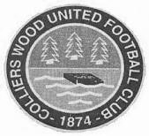
Colliers Wood United FC was founded way back in 1874 and the early years of their existence were spent in the Wimbledon and Sutton leagues before moving on to the Surrey Intermediate League (Southern Division). During the late sixties and early seventies, the club were members of the Surrey Senior League for a short time, playing in the newly formed division one where they won the league title in 1969/70. Over the years, “The Wood” has reached a number of Surrey FA Cup Finals. In 1988/89 they lost 1-2 to Bradbank Sports in the Intermediate Cup Final and in 1991/92 they beat Woking & Horsell 4-0 in the final of the same competition.

The local recreation ground prevented the progress of the club due to the limited facilities and a search for a new ground was launched. Adequate facilities were found at Wibbandune Sports Ground in 1991 and the ground has steadily improved since then.

2001/02 saw the club enter the Surrey County Senior League where they finished a creditable 5th. The following season, they finished as runners up. In 2002/03, the league amalgamated with the Combined Counties League and the club were founder members of the new Division 1 where they finished as runners up and were promoted to the Premier Division.

They have continued to improve. In 2004/05, they finished 14th of the 24 clubs. The following season, they finished fourth and had a fine FA Vase run, beating Chichester City United, Raynes Park Vale and Greenwich Borough, before losing to VCD Athletic in the 2nd Round.

In 2006/07 they entered the FA Cup for the first time, defeating Chipstead after a replay before succumbing to Worthing 0-3.

After a brief ground share at Croydon FC, the club moved back to Wibbandune where ground improvements included the addition of excellent floodlighting, a new covered terrace and a 120 seat stand.

In March 2012, the club added a new away team changing room, new spectator ground lavatories and re-laid the entire playing surface including drainage thanks to a £71,000 grant from the Football Association. They also reached the 2011/12 final of the League Cup at Farnborough FC on 4th May v Guernsey FC in front of 667 spectators, which they lost 0-2 after extra time, becoming the first club to keep a 90 minute clean sheet against The Islanders. Following a second renovation of the pitch in April, the club returned to Wibbandune in July 2013 and the under 18 youth section was re-started.

In 2014/15, Wood have reached the FA Vase 4th round (last 32 nationally) and the Surrey Senior Cup quarter finals for the first time in their history. They reached the final of the League Cup again in 2014/15, but once more lost in extra time, this time 1-2 to Camberley Town in front of 385 spectators at Woking FC. On Tuesday March 8th 2016, the club were awarded the FA Charter Standard status by the Football Association. This has now been extended to March 2018.

The club won the CCL Sportsmanship Award for 2015/16 having received just 32 cautions throughout the season.

Banstead Athletic – History
One of the few clubs to be founded during the Second World War Banstead began football activities in the season 1944-45 under the name Banstead Juniors, playing in the Epsom & Ewell League at Tattenham Way Recreation ground.

In their first season they won the League Cup and finished runners up in the League. The following season they joined the Sutton & District League that Epsom and Ewell, as Epsom Juniors, had once been founder members of, and by the end of the year achieved promotion to the Surrey Intermediate League. During the close season of 1946/47 they changed the name of the club to Banstead Athletic F.C.

In their first year in the League ‘Athletic’ won the Surrey Intermediate Cup and the following two seasons captured the League title. After five successful years at junior/intermediate level, Banstead achieved senior status and joined the Surrey Senior League for season 1949/50.

The promotion to senior football marked the start of ‘Banstead’s Glory Days’, as the next decade brought them an abundance of honours. In the first season of senior status Banstead achieved runners up position to Leatherhead. Their success owed much to the prolific goal scoring of Harry Clark who netted 104 goals.

Before the commencement of season 1950/51 Banstead moved from the Recreation ground to their present headquarters at Merland Rise. The first season at the new ground saw Athletic win the League title from Dorking by a margin of 11 points. Harry Clark only managed 81 goals in 26 games! They proceeded to win the title for the next three seasons, making it a record four continuous championships.

In the following five years they achieved one more title success (1956/57) and four runners up positions. In addition they were winners of six Surrey County Cup competitions.

The period 1959–1964 was a barren time for Banstead with only one notable achievement, the winning of the East Surrey Hospital Charity Cup in 1959/60. However, under the management of Gordon Taylor the League title was won again in 1964/65.

Owing to having only a short term lease arrangement the club were unable to obtain the necessary financial support to enhance ground facilities, which severely restricted their ambitions of playing in a higher grade of football. When in 1965 the club received promises of a long term lease they joined the Spartan League for season 1965/66. In the first two seasons Banstead reached the League Cup Final, losing on both occasions to Hampton.

During nine seasons in this League their highest achievement was 5th position. However in 1966/67 they won the East Surrey Hospital Charity Cup by beating Redhill 4-0. In 1975/76 the League became the London Spartan League and Banstead finished runners up in 1977/78. The club beat Whyteleafe to win the East Surrey Hospital Charity Cup in 1976/77 and were beaten finalists the following year.

Banstead joined the Athenian League in 1979/80 and won the League Cup in 1980/81, beating Windsor & Eton 1-0. The following season they successfully defended the trophy defeating Uxbridge 1-0 after a replay. One year later (1982/83) they lost to Chalfont St. Peter in the final by two goals to one.

With the demise of the Athenian League Banstead joined the Isthmian League Division Two (South) in 1984/85 and in their first season finished 9th. Towards the end of season 1989/90 the club faced closure due to the resignation of the Chairman and his family Directors over differences with the local council on ground leasing. Fortunately our then Reserve team manager Terry Molloy rescued the club by negotiating a settlement with the previous Chairman and the council to become the new owner and Chairman of Banstead Athletic. He then improved facilities at Merland Rise with the installation of new floodlights and the upgrading of clubhouse amenities. The team did well enough to reach 11th position in season 1990/91 and saved the club from the drop into the newly formed third division.

The club then appointed joint Managers in Bob Mapleson and Mickey Sorensen. In their first season (1992/93) Banstead had their best ever run in a major Cup competition when they reached the FA Vase Quarter-finals, and were beaten 1-0 by the eventual Vase winners Bridlington Town, however because of the large backlog of League matches at the end of the season Banstead finished in 13th place.

Banstead were approached by their near neighbours Epsom & Ewell to ground share at Merland Rise for the 1993/94 season as Epsom’s ground had been sold for redevelopment. An agreement was reached but Banstead had to carry out considerable ground improvements to acquire a Grade C rating. With the help of Epsom & Ewell this was achieved at a cost of £40,000.

League and Cup success eluded the club in seasons 1993/94, when they finished in 9th place and in 1994/95 when fading out of the promotion battle to finish in 8th spot. Good runs in the Carlsberg Trophy, FA Vase and Surrey Senior Cup kept interest alive, whilst further ground improvements secured a B Grading.

The 1995/96 season proved to be one of the clubs more eventful and eventually frustrating seasons in recent years. Promotion was snatched from their grasp in the final match at Wivenhoe, and a last minute Peacehaven goal brought elimination at the 5th round stage of the F.A. Vase, whilst Canvey Island beat us 2-1 in the final of the Carlton Trophy.

A poor start to the 1996/97 League campaign plus an end of season schedule of 17 games in 40 days virtually ruled out a serious promotion bid, but a fabulous and exciting run in the Vase saw the club reach the Semi-finals and after two tremendous tension-filled games, eventual Vase winners Whitby Town emerged 2-1 aggregate winners.

Nevertheless the media attention lifted the profile of the club. Manager Bob Langford and player/coach Mickey Stephens had the task of rebuilding the side in 1997/98 as several of the longer serving and better quality players left for pastures new and as a result Banstead struggled to achieve consistency. Out of all Cup competitions before the end of December and a final League position of 13th summed up what was a transitional period for the club.

The 1998 /99 season saw Banstead hovering around the top four places in the table for most of the campaign, but were unable to clinch a promotion spot and Bob Langford stood down as Manager at the season’s end. New manager Chick Botley previously with Hampton replaced Langford for season 1999/2000, however after just eight games Botley resigned as Manager and Bob Langford was recalled to the Manager’s chair. Ray Best, previously Manager at Molesey was brought in by Langford as Assistant Manager and Mickey Stratford took on the role of Coach.

A clear out of players brought in by Botley took place and it took time for Langford’s squad to settle in. The League campaign was a struggle to keep out of the relegation zone. However a splendid end of season run of seven victories in eight games saw the club finish in a very respectable tenth position. Defeats at the first hurdle in the FA Cup, FA Vase, League Cup and County Cup were offset by a good run in the Vandanel Trophy which ended at the 4th round stage, and silverware was gained in the East Surrey Charity Cup when Chessington United were beaten 2-0 in the final.

In the 2006/07 season we resigned from the Isthmian League and joined the Combined Counties League. During the period 2006-2013 there were a number of managers and assistant managers, Graeme Banyard, Dave Leworthy, Barry Barnes, Paul Norris, Russell Harmsworth, & Bobby Knock, Dave Tidy, Perry Gough, Paul Elsey, Andrew Tucker, Michael Watson, Danny Lee, Nicky Bolt. However, relegation occurred in 2012 and the club fell to Step Six.

In July 2015 Gordon Taylor-President of this club passes away and in December 2015 Len Walker a former central defender died. However, things started to improve and in 2015/16 the club finished 6th in Division One after being in a good position with a few games left and they won best administered club in the First Division.

In 2016/17 there was to be no mistake as they won the League title, remaining unbeaten in league contests since October 2016 under the management of James Cameron & Rod Davis and with Martin Smith as top goalscorer for the club with 40 goals.

The club now competes once again at Step Five football at a different looking Merland Rise to the one many of their opponents will remember from 2012. A new leisure centre covers the old Reserve pitch and somewhat dominates the landscape as the area surrounding Merland Rise begins to sprout a number of new housing developments.

Player Sponsorship
Here is the latest list for 2017/18, with new photos showing all of our players and Management that are available for sponsorship.

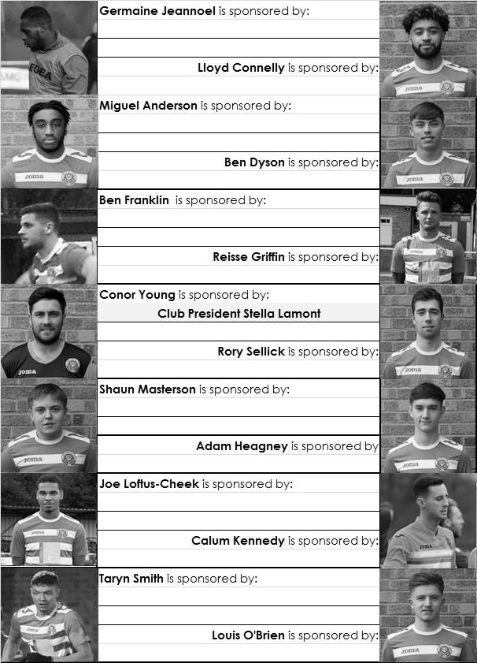

Sponsorship costs just £40 and it is easy to do. Just select a player who has not been previously sponsored and let a Committee Member know. Don’t delay, sponsor today!

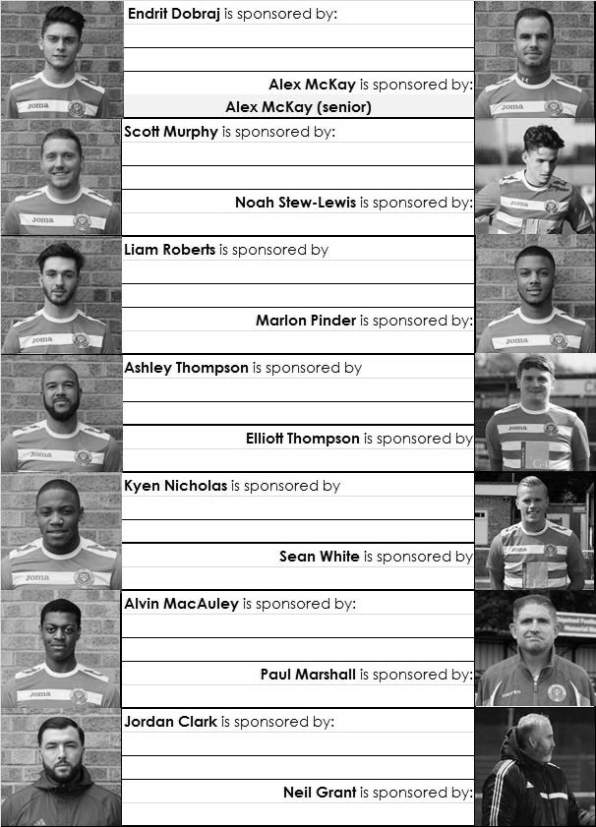

Every Opponent A-Z
Over the years we have played many, many different opponents. Exactly how many is a difficult question, as it all depends on your definition. Are Camberley & Yorktown different to Camberley Town, or are Epsom Town different to Epsom F.C. or Epsom & Ewell F.C.?

In my analysis I have classed them as the same team, and will work through them all from A to Z. Some we have played many times, whilst others we have met maybe just once or twice. Enjoy!

Wokingham Town: Played 32 - W11 D4 L17 - F53 A60 - PPG - 1.16 - Below Average

It seems quite some time ago that we last met Wokingham Town, who effectively dropped off the football map a few seasons later, but they do still exist even if their old ground is long gone.

Meetings with them can be packaged into three distinct eras with a fairly large gap in between each. They first met us on Boxing Day 1959 as a new Corinthian League team, having joined from the Delphian League that summer. We turned around a half time deficit to win 2-1 in that match and on our first visit to Finchampstead Road on Monday 18th April we completed a double with a 3-1 win.

We were a good team that season, winning the League Cup a couple of weeks later, and we continued to hold the upper hand the following season when a 1-1 away draw was followed by a 1-0 home win in February of 1961; Dave Mollatt the scorer. However, 1961/62 was the start of a decline for our team that would not reverse for over a decade and in the four meetings over the next two seasons we lost the lot!

The Corinthian League was then absorbed by the Athenian League in 1963 and the losing run was extended to five before we produced an incredible 7-2 win over them on 28th March 1964 at West Street with Bill Mackay and Tony Monk scoring hat tricks!

We even won our next meeting in September 1964 as we were paired together in the F.A. Cup with MacKay getting another hat trick in a 4-2 win but it would be a long while before we could celebrate a victory again as we drew 2-2 at home and lost 3-0 in Wokingham in the April of 1965 and were relegated a month later.

We dragged along in the Second Division of the Athenian League while they did much the same in the division above, until 1972/73 when we were of course relegated to the Surrey Senior League and they finished fifth in Division One and gained promotion to the newly formed second division of the Isthmian League, where they promptly finished bottom of the League in 1973/74.

They stabilized after this and remained in the Second Division until 1977/78 when it was renamed Division One to accommodate the new batch of joiners, which of course included Epsom & Ewell. We won the Division Two title in that first season and were back in the same League for 1978/79.

We played three times in that season, losing a Southern Combination Cup tie but more importantly winning the two League matches without conceding as we settled into our new surroundings. 1979/80 also contained three meetings with an F.A. Trophy tie at Finchampstead Road going their way by two clear goals and they also won the two League matches too for good measure!

In 1980/81 we were a much improved team and would be denied promotion only by two terrific sides; three time F.A. Vase winners Billericay Town and Bishops Stortford who would go on to win the F.A. Trophy that year, an incredible achievement for a club of that level. Neither of those teams beat us that season and nor did Wokingham Town, although draws were our weak spot this year,

and we were held 1-1 in November 1980 at West Street, although we had won 3-0 back in August on their patch. In 1981/82 it was their turn to push for promotion and they would become Champions, edging us out 1-0 in October 1981, just a week before I started watching the club, but also winning 3-1 on a balmy Tuesday April evening at West Street, by which time the team had much changed following the O’Connell walkout in the February. Steve Hill remained and he scored the goal, but we would have to wait until 1984 before we would join them in the Premier Division.

By this time they were an established team, having reached the First Round of the F.A. Cup in 1982/83 when Millwall caused a lot of damage to their ground. We hosted them on 23rd March 1985, drawing 1-1 and we went better still winning there 4-1 on a Thursday evening on 2nd May and denying them a top three finish. They had to settle for fourth place, although would eventually finish runners up in the Isthmian League in 1990 by which time of course, we had fallen down two flights. Wokingham had in fact relegated us in May 1986 when we went into the match needing a win and some help but got neither! It would be nearly eleven years before we would meet again.

But problems were not far away for Wokingham Town either. They were relegated in 1995 and again in 1998 with a third relegation in 2001. During this time we had met at Finchampstead Road in the Southern Combination Cup, losing in 1997 but winning 1-0 on our final visit there on 1st April. By then they knew they were leaving their ground and this was one of their final matches played there. It was not a particularly inspiring venue but as all old Epsom supporters will know, it was home and an uncertain future beckoned.

A nomadic existence occurred for a while with matches played at Bracknell Town and Windsor & Eton, which is where we met for a season in 2001/02, leading early but losing Paul Sears to an unnecessary sending off which then turned the match into a 2-5 defeat. Our final meeting came on 20th April 2002 while we were chasing promotion in the League reorganisation and battered them 5-1 at Merland Rise with our promotion being confirmed a week later at Flackwell Heath.

They remained there for two seasons until 2004 when the League reorganisation into Steps occurred. However, they would not be a part of it though, as they took voluntary demotion and merged with local club Emmbrook Sports. They remain at Lowther Road to this day, playing at Step Six in the Hellenic League East Division.

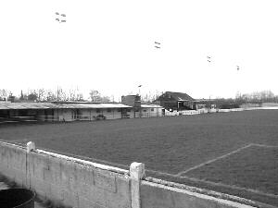
A view of the old Wokingham Town ground at Finchampstead Road nearing the end of its life

Combined Counties League Premier Division
Opponents All-time Records
inc Saturday  24th March | P | W | D | L | F | A | PPG | GD | Best  Win | Worst  Loss
Horley Town | 32 | 21 | 5 | 6 | 71 | 37 | 2.13 | +34 | 6-0 | 1-3
Banstead Athletic | 38 | 23 | 7 | 8 | 62 | 38 | 2.00 | +24 | 5-0 | 0-4
Sutton Common Rovers* | 15 | 9 | 3 | 3 | 30 | 21 | 2.00 | +9 | 4-0 | 0-5
Spelthorne Sports* | 9 | 5 | 3 | 1 | 16 | 11 | 2.00 | +5 | 6-2 | 1-5
Godalming Town | 3 | 2 | 0 | 1 | 4 | 5 | 2.00 | -1 | 2-1 | 0-3
Colliers Wood United | 24 | 14 | 2 | 8 | 47 | 39 | 1.83 | +8 | 4-0 | 0-5
Abbey Rangers | 6 | 3 | 2 | 1 | 12 | 5 | 1.83 | +7 | 7-1 | 2-3
Farnham Town | 17 | 9 | 4 | 4 | 30 | 25 | 1.82 | +5 | 3-0 | 1-4
Guildford City | 19 | 11 | 1 | 7 | 36 | 25 | 1.79 | +11 | 5-1 | 1-5
Westfield | 22 | 12 | 3 | 7 | 43 | 41 | 1.77 | +2 | 6-1 | 0-5
Bedfont Sports | 13 | 7 | 2 | 4 | 23 | 23 | 1.77 | 0 | 5-1 | 0-7
Knaphill | 10 | 5 | 2 | 3 | 20 | 16 | 1.70 | +4 | 4-0 | 2-6
Hanworth Villa | 19 | 9 | 5 | 5 | 42 | 30 | 1.68 | +12 | 5-0 | 1-4
Walton & Hersham | 53 | 25 | 11 | 17 | 105 | 101 | 1.62 | +4 | 8-0 | 1-9
Camberley Town** | 92 | 38 | 24 | 29 | 159 | 126 | 1.50 | +33 | 9-1 | 0-4
Redhill | 35 | 14 | 2 | 19 | 63 | 77 | 1.26 | -14 | 7-2 | 2-8
Chertsey Town | 51 | 19 | 5 | 27 | 77 | 95 | 1.22 | -18 | 3-0 | 0-7
North Greenford United | 13 | 4 | 2 | 7 | 19 | 24 | 1.08 | -5 | 3-0 | 1-4
AFC Hayes | 11 | 2 | 3 | 6 | 18 | 20 | 0.82 | -2 | 7-0 | 0-3
CB Hounslow United | 4 | 1 | 0 | 3 | 6 | 11 | 0.75 | -5 | 2-0 | 1-5
Balham | 2 | 0 | 0 | 2 | 0 | 6 | 0.00 | -4 | x | 0-4
* includes one loss on penalties v Spelthorne and one win on penalties v Sutton Common Rovers
** includes one abandoned match v Camberley

Match and Ball Sponsorships – 2017/18
Opponent | Date | Match Sponsor | Ball Sponsor
Banstead Athletic (FAC) | 06/08/17 | Club President - Stella Lamont
Chertsey Town | 15/08/17 | EEFC Management Committee
Redhill | 02/09/17 | Building Shop Ltd
Spelthorne Sports | 09/09/17 | In memory of Betty Dyke
Horley Town | 12/09/17 | Alex McKay (Senior)
Hanworth Villa | 23/09/17 | Jack Jarman
North Greenford United | 28/10/17 | Marvin and Kathy Hough
Farnham Town | 14/11/17 | In memory of Dave and Lizzie Marshall
Godalming Town | 21/11/17 | Building Shop Ltd
Guildford City | 02/12/17 | John Bonner
Walton & Hersham | 30/12/17 | Jeff and Arnold Pye
Merstham (SSC) | 16/01/18 | Paul Merritt
Abbey Rangers | 23/01/18 | Pete Beddoe’s grandchildren  George, Joseph, Ezara & Inaya
Sutton Common Rovers | 03/02/18 | David Ellins
Knaphill | 24/02/18 | Jack Jarman
Camberley Town | 10/03/18 | Pete Lumm
Balham | 13/03/18
Bedfont Sports | 24/03/18 | EEFC Management Committee
Colliers Wood United | 30/03/18
Banstead Athletic | 02/04/18 | Nathan Lambert – 10 years old today!
Westfield | 14/04/18
CB Hounslow United | 17/04/18
AFC Hayes | 28/04/18 | Club President - Stella Lamont
Match sponsorship costs just £60.00!

Sponsorship includes:

Admission, programmes and hospitality for three people.

A full page advert in the programme and mascot for the day (if required).

Also, you get to choose the player of the match, who will receive a prize

If you are interested, just speak to a Committee Member,
or drop me an email at: richard.c.lambert@gmail.com

Salts Super Six Predictor
The Salts Super Six Predictor jackpot is now at £225 for today’s match. The tickets are on sale to the left of the gate and the matches on the ticket are to be played on Saturday 31st March with further fixtures on a new ticket which will be played on Saturday 7th April.

The competition is easy to play! To win, you simply need to predict the results of six matches correctly from the three options, fill in the form and make sure it is back with our seller before the deadline on the ticket. The latest fixtures are shown below.

If you are a club regular, you just need to place your name on the sheet, although if you aren’t, then we’ll need a contact number from you too. We will announce any winners on the website within three working days, so don’t worry, we won’t miss you!

Please note that if there is more than one winner, the prize pot would be shared between the winners. All you need to do now is have a go, as many times as you like!

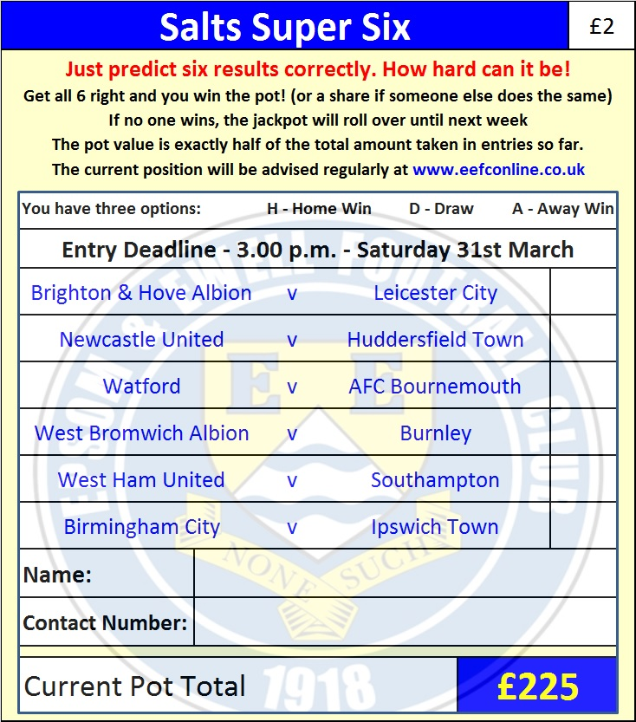

Good luck!

Combined Counties League – Premier Division
Friday, 30th March 2018 - Kick-off 11.30 a.m.
Epsom and Ewell  (Royal Blue & White hoops) | V |  | Colliers Wood United  (Red and White)
Squad | NUMBERS |  | Squad
Conor Young |  |  | Sean Fallon
Endrit Dobraj |  |  | Aaron Stephens
Reisse Griffin |  |  | Dan Hughes
Adam Heagney |  |  | Carlos Talbot
© Alex McKay |  |  | Jake Hill
Ashley Thompson |  |  | Tyrone Newton ©
Marlon Pinder |  |  | Reanu Grossett
Scott Murphy |  |  | Mo Mohammed
Kyen Nicholas |  |  | William Efambe
Rory Sellick |  |  | Charlie Emery
Lloyd Connelly |  |  | Mario Embalo
Ben Dyson |  |  | Jordan Esprit
Liam Roberts |  |  | Kieran Russell
Miguel Anderson |  |  | Theo Woodhouse
Ben Franklin |  |  | Tate Greenaway
Shaun Masterson |  |  | Bas Morally
Joshua Caulcrick |  |  | Joswar Gonzalez
Jordan Clark |  |  | Simeon Dennis
Alvin MacAuley |  |  | Joshu Antonio
Noah Stew-Lewis |  |  | Ryan Doherty
Germaine Jeannoel
Neil Grant | MANAGER |  | Tony Hurrell
Alex McKay | ASSISTANT |  | Paul Doherty
Jordan Clark | COACH / PHYSIO |  | Steve Turner / Ryan Lock
REFEREE: S.Matthews
ASSISTANTS: W.Ingram, S.Tyler

OUR NEXT VISITORS TO HIGH ROAD
Westfield
Cherry Red Combined Counties League – Premier Division
Saturday 14th April 2018 – 3.00 p.m.

Combined Counties League – Premier Division
Monday, 2nd April 2018 - Kick-off 11.30 a.m.
Epsom and Ewell  (Royal Blue & White hoops) | V |  | Banstead Athletic  (All Red)
Squad | NUMBERS |  | Squad
Conor Young |  |  | Sean Bradley
Endrit Dobraj |  |  | Tom Drinkwater
Reisse Griffin |  |  | Billy Frost
Adam Heagney |  |  | Robert Hill
© Alex McKay |  |  | Joseph Kelly
Ashley Thompson |  |  | Leonel Medrado
Marlon Pinder |  |  | Anthony Morrison
Scott Murphy |  |  | Matthew O’Brien
Kyen Nicholas |  |  | Francisco Ramos
Rory Sellick |  |  | Harry Wise
Lloyd Connelly |  |  | Danny Penfold
Ben Dyson |  |  | Jake Connaris
Liam Roberts |  |  | Jake Treagus
Miguel Anderson |  |  | Dan Jones
Ben Franklin |  |  | Kofi Quartey
Shaun Masterson |  |  | Daniel Rose
Joshua Caulcrick |  |  | Anson Cousins
Jordan Clark |  |  | Liam Holden
Alvin MacAuley |  |  | Jake Richards
Noah Stew-Lewis |  |  | George Smith
Germaine Jeannoel |  |  | James Holden
Neil Grant | MANAGER |  | James Cameron
Alex McKay | ASSISTANT |  | Rod Davis
Jordan Clark | COACH / PHYSIO |  | Megan C-Jones / Andy Smith
REFEREE: Z.Jacquart
ASSISTANTS: to be announced
Today’s Match and Match Ball are kindly sponsored by:
Nathan Lambert who is ten years old today!

OUR NEXT VISITORS TO HIGH ROAD
Westfield
Cherry Red Combined Counties League – Premier Division
Saturday 14th April 2018 – 3.00 p.m.

